**PROJECT DOCUMENTATION**

***Step-by-Step Project Development Procedure***

**Online Education System**

**1. Data Collection**

1. ***Collecting the Dataset***

The following Dataset named: Online Education System Review downloaded from

Kaggle website using following Link

<https://www.kaggle.com/datasets/sujaradha/online-education-system-review>

1. ***The Downloaded file has the file name***

ONLINE EDUCATION SYSTEM REVIEW.csv

1. ***Column Description for Online education system review:***

Gender: Gender of the student

Home Location : Rural or Urban.

Level of Education : UG, PG or school

Age : age of the student

Number of subjects :

Device Type Used : device used to attend the online classes

Economic status : economic status of the family

Internet facility in your locality

Are you involved on any sports

Family Size

Do elderly people monitor you ?.

Study Time(hours)

Sleep time (hours)

Time spent on social media(hours)

Interested in gaming ?

Have a separate room for studying ?

Engaged in group studies ?

Average marks scored before pandemic in traditional classroom

Your interaction in online mode

Clearing doubts with faculties online ?

Interested in ?

Performance in online

Your level of satisfaction in online education

1. ***Connect the Data with IBM Cognos***

Step 1: Open the IBM Cognos Login

Step 2: Select Upload Data using menu

Step 3: Select the My Content option in that select the ONLINE EDUCATION SYSTEM REVIEW.csv file to upload

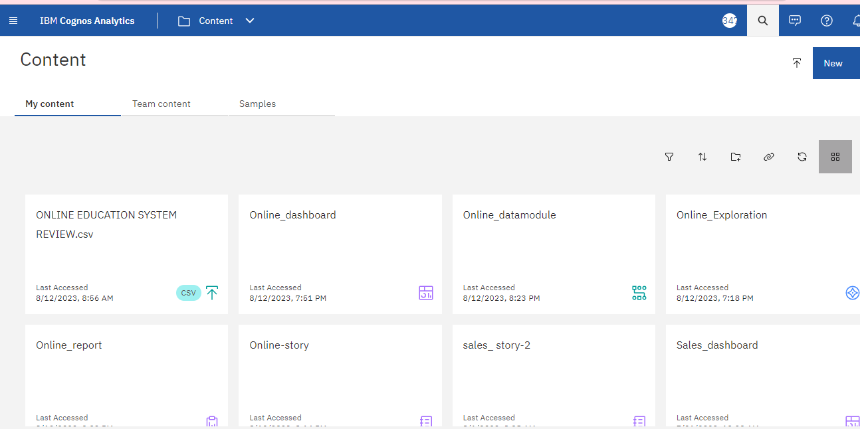

**2. Data Preparation**

a. Prepare the Data for Visualization

Step 1: Click on Menu> Click on New> Select Data Module

Step 2: Select your Dataset> Click on Ok button in Bottom of Page

Step 3: Select Table> Click on Next Button

Step 4: Tick Next to Online Education System Review.xls so that all tables get selected and click on Ok

Step 5: To preview the data , double click on any of the data fields

Step 6: If you want to rename any field, click on the ‘three dots’ at the right side of the field

Step 6: To Save Data Module:

1. Click on Save icon below Menu bar>
2. Put name as “Online_datamodule”
3. Select My Content
4. Click on Save

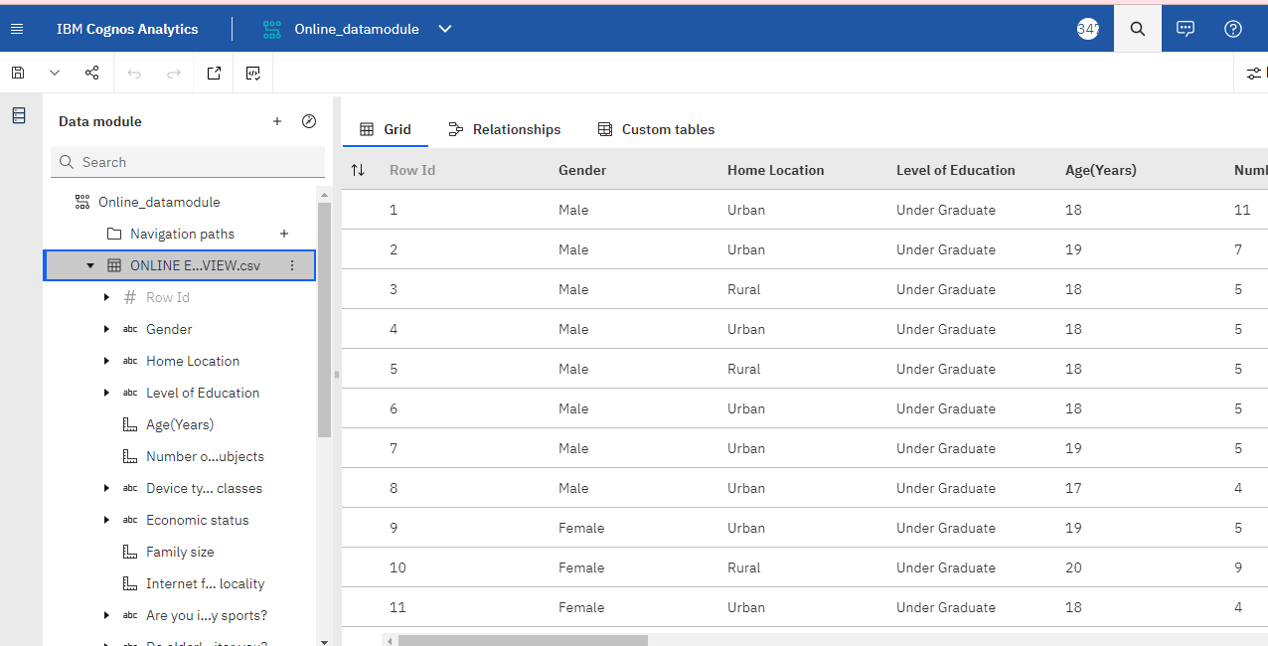

**3. Data VISUALIZATION**

Click on Menu> Select New> Select Exploration

Click on My content> Select Online_datamodule

Click on Add

Click on Create+ > Select Single Visualization Card

***a. Column Chart:***

Step 1: Click on Choose Type> Select Column Chart:

Step 2: Drag ‘Your level of satisfaction with online education’ into Bars

Step 3: Drag ‘Age’ into Rows.

Step 4: Click on Pins to add visualisation to My Pins

Step 5: Click on Save> Save As> Online_Exploration>

Step 6: Select My Content> Ok

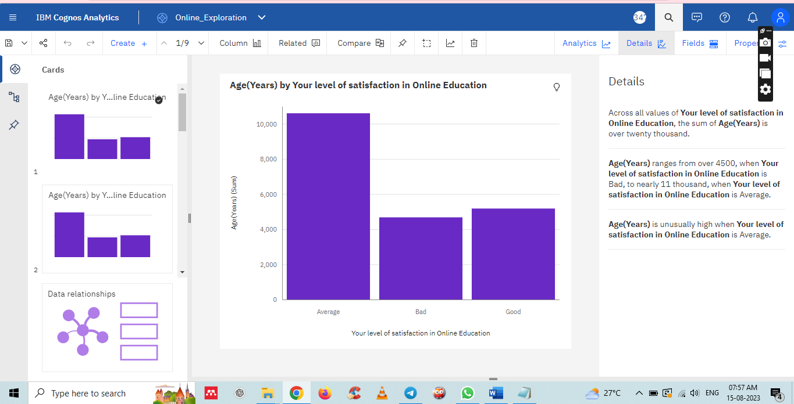

***b. Bar Chart:***

Step 1: Click on Choose Type> Select Bar Chart:

Step 2: Drag ‘Your level of satisfaction with online education’ into Bars

Step 3: Drag ‘internet facility in your locality’ into length

Step 4: Click on Pins to add visualisation to My Pins

Step 5: Click on Save> Save As> Online_Exploration>

Step 6: Select My Content> Ok

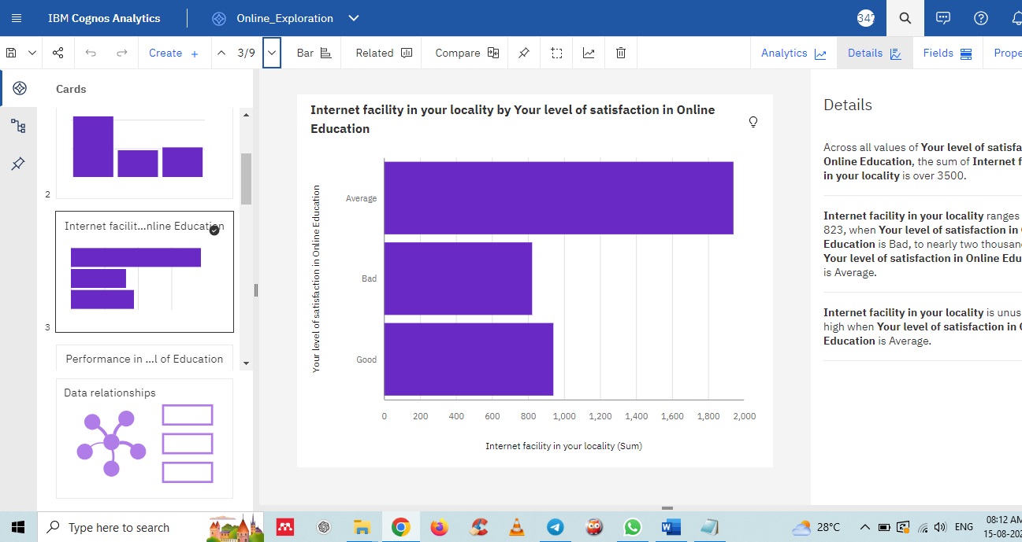

***c. Bar Chart:***

Step 1: Click on Choose Type> Select Bar Chart:

Step 2: Drag ‘Level of Education’ into Bars

Step 3: Drag ‘Performance in online’ in length

Step 4: Click on Pins to add visualisation to My Pins

Step 5: Click on Save> Save As> Online_Exploration>

Step 6: Select My Content> Ok

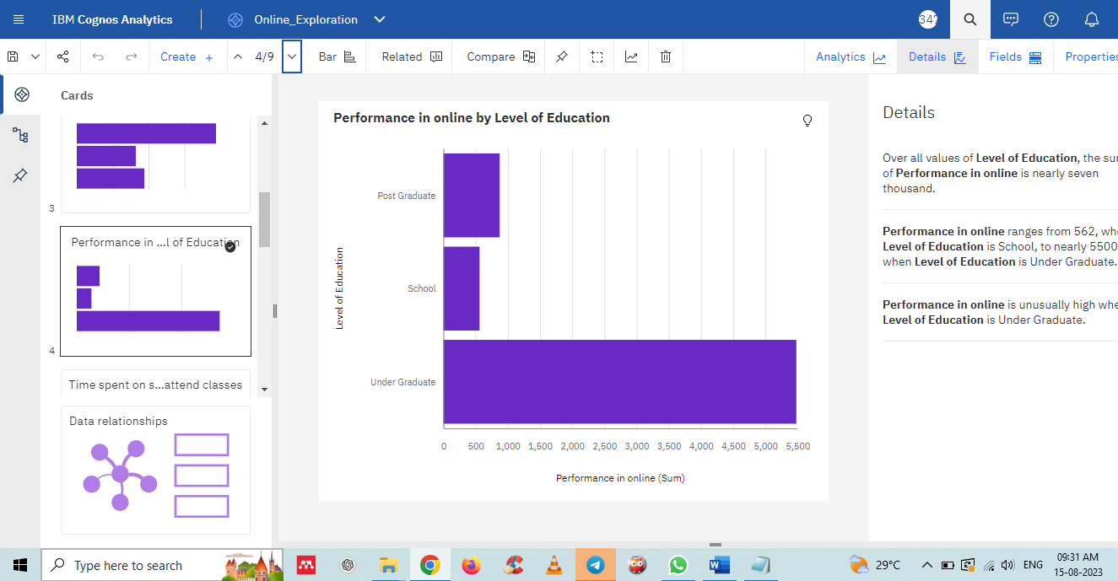

***d. Pie Chart:***

Step 1: Click on Choose Type> Select Pie Chart:

Step 2: Drag ‘Level of Education’ into Bars

Step 3: Drag ‘Performance in online’ in length

Step 4: Click on Pins to add visualisation to My Pins

Step 5: Click on Save> Save As> Online_Exploration>

Step 6: Select My Content> Ok

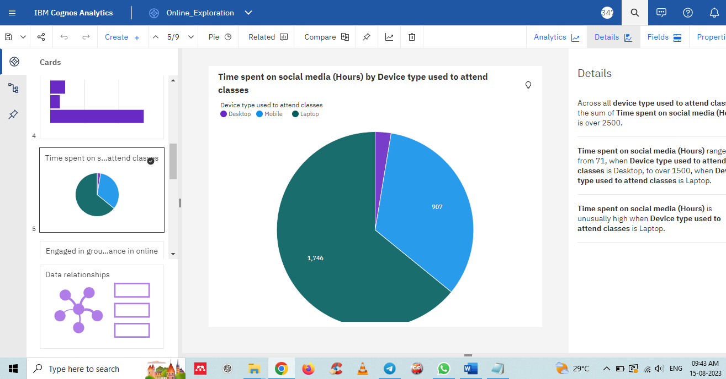

***e. Packed Bubble:***

Step 1: Click on Choose Type> Select Packed Bubble:

Step 2: Drag ‘Engaged in group studies’ into Bubbles and color.

Step 3: Drag ‘Performance in online ’ into Size.

Step 4: Click on Pins to add visualisation to My Pins

Step 5: Click on Save> Save As> Online_Exploration>

Step 6: Select My Content> Ok

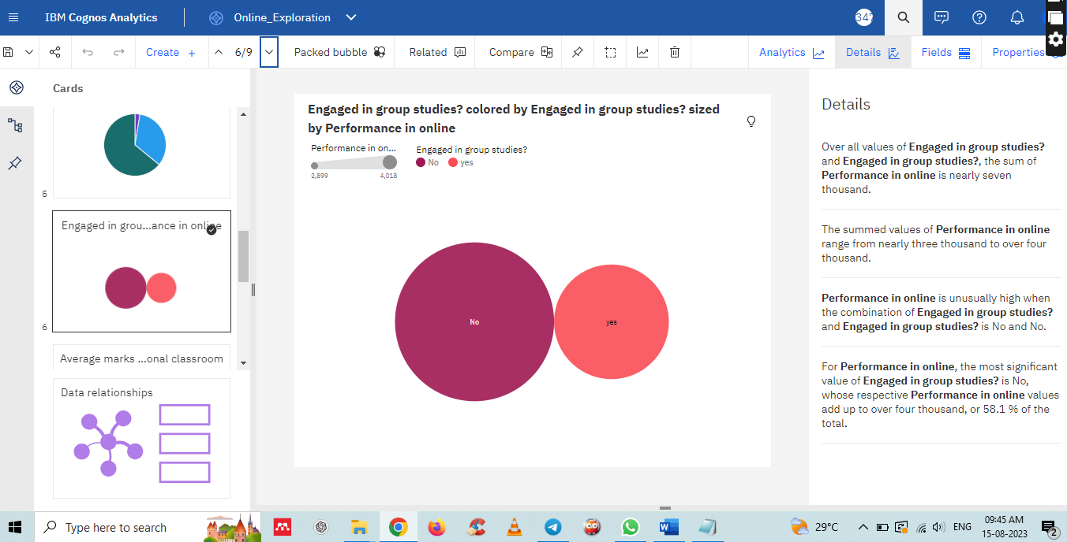

***f. Word Cloud:***

Step 1: Click on Choose Type> Select Word Cloud:

Step 2: Drag ‘Average marks scored before pandemic in traditional classroom ‘ in both words field & size field.

Step 3: Click on Pins to add visualization to My Pins

Step 4: Click on Save> Save As> Online_Exploration>

Step 5: Select My Content> Ok

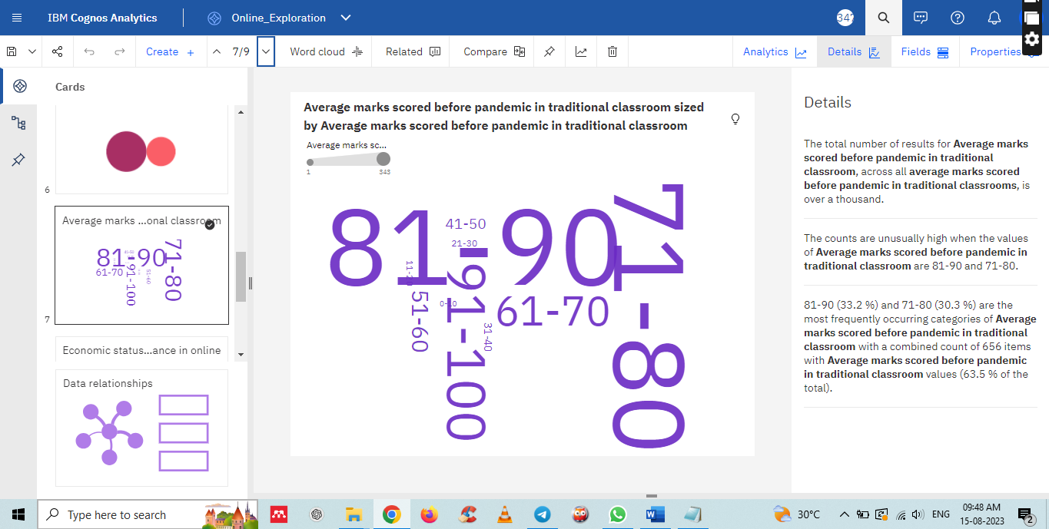

***g. Table:***

Step 1: Click on Choose Type> Table:

Step 2: Drag ‘Economic status’ , ‘Home Location’ & ‘ Performance in online’ in columns

Step 3: Click the ‘three dots’ in the ‘performance in online ‘ field and click on ‘summarize’ option and then select ‘average’

Step 4: Click on Pins to add visualization to My Pins

Step 5: Click on Save> Save As> Online_Exploration>

Step 6: Select My Content> Ok

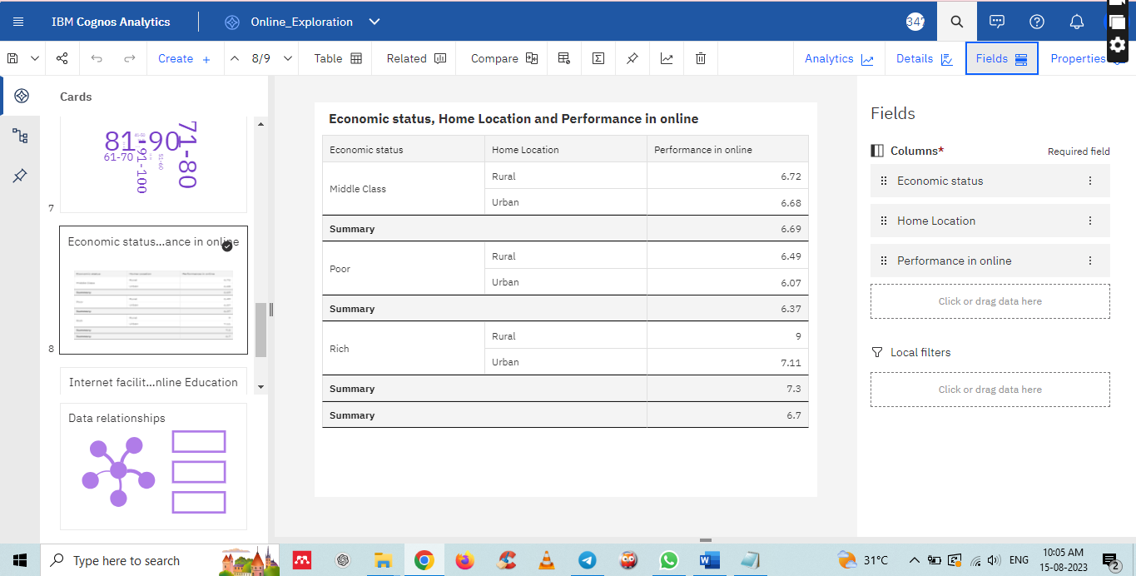

***h. Radial Chart:***

Step 1: Click on Choose Type> Radial:

Step 2: Drag ‘Your level of satisfaction with online education’ into Bars

Step 3: Drag ‘Internet facility in your locality’ into length.

Step 4: Click on Pins to add visualization to My Pins

Step 5: Click on Save> Save As> Online_Exploration>

Step 6: Select My Content> Ok

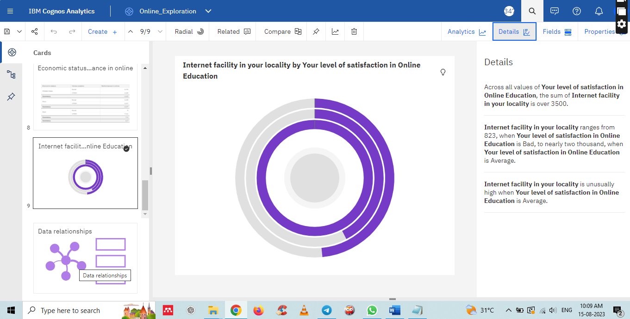

**4. Data dashboard**

* Create a dashboard: Once you have created the explorations, you can create a dashboard by clicking the "present data'' option & selecting the dashboard.
* you can drag the visualizations from the ‘pin’ option present at the left side of the screen.
* whenever you create a visualization in ‘explorations’, make sure to pin them, after pinning the visualization you can drag them on to the dashboard.

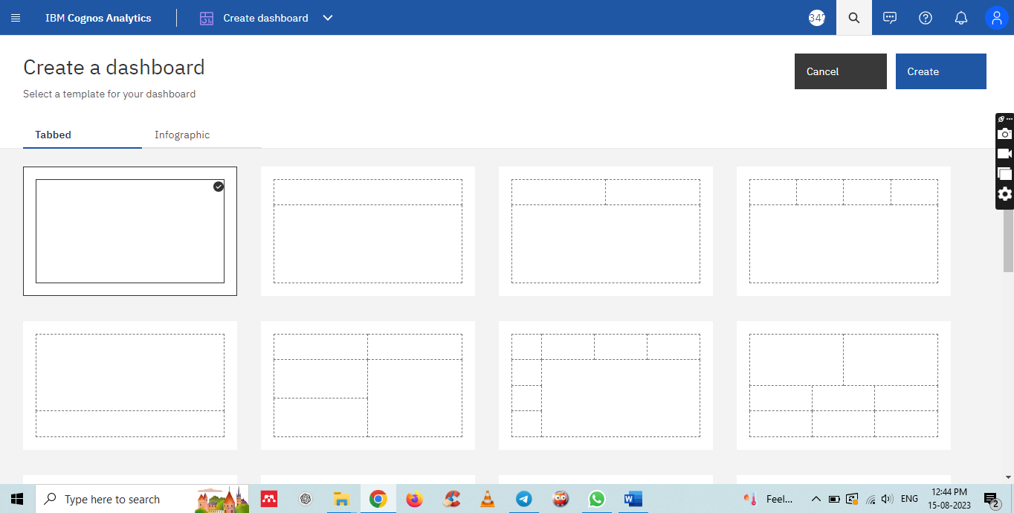

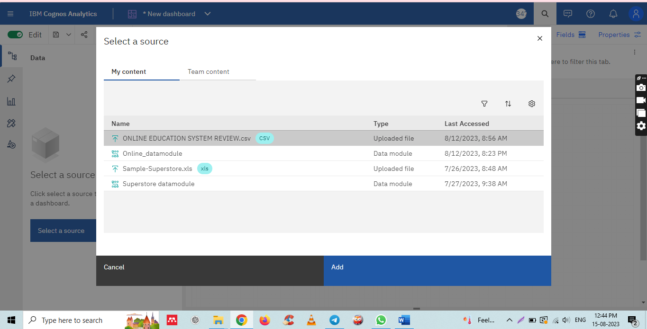

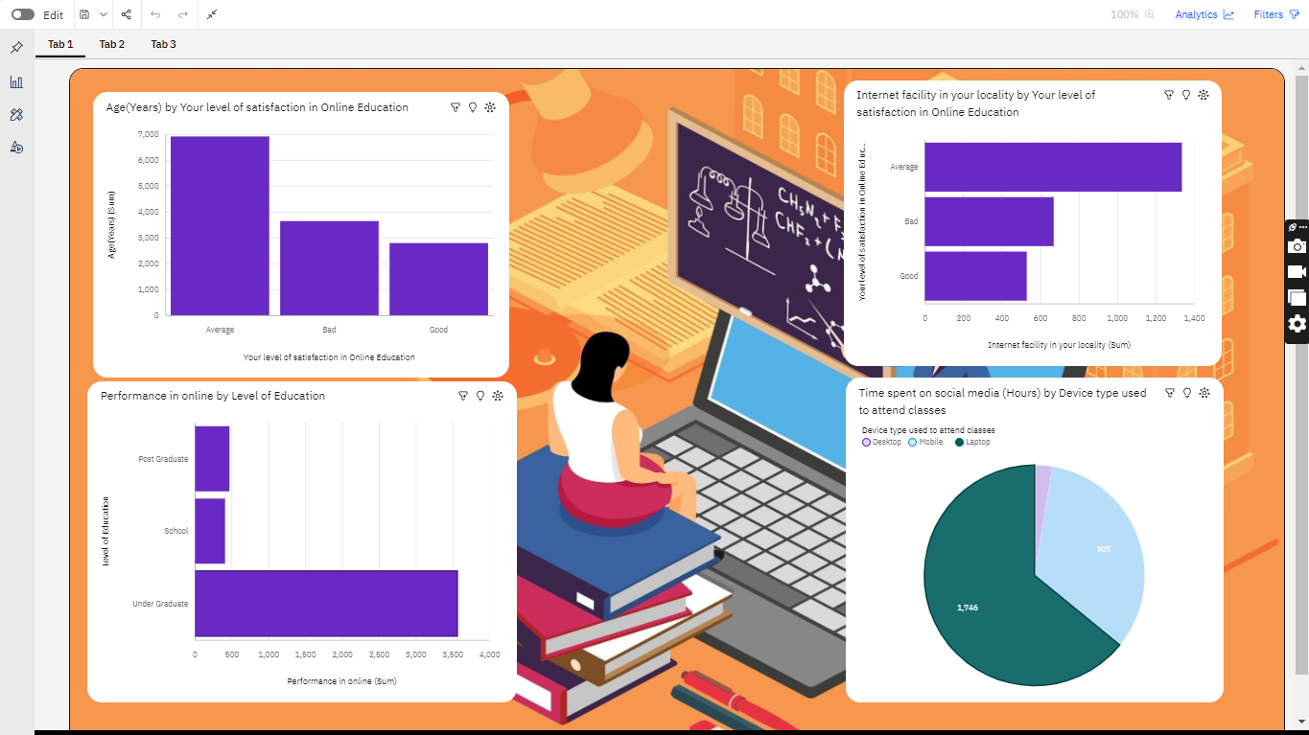

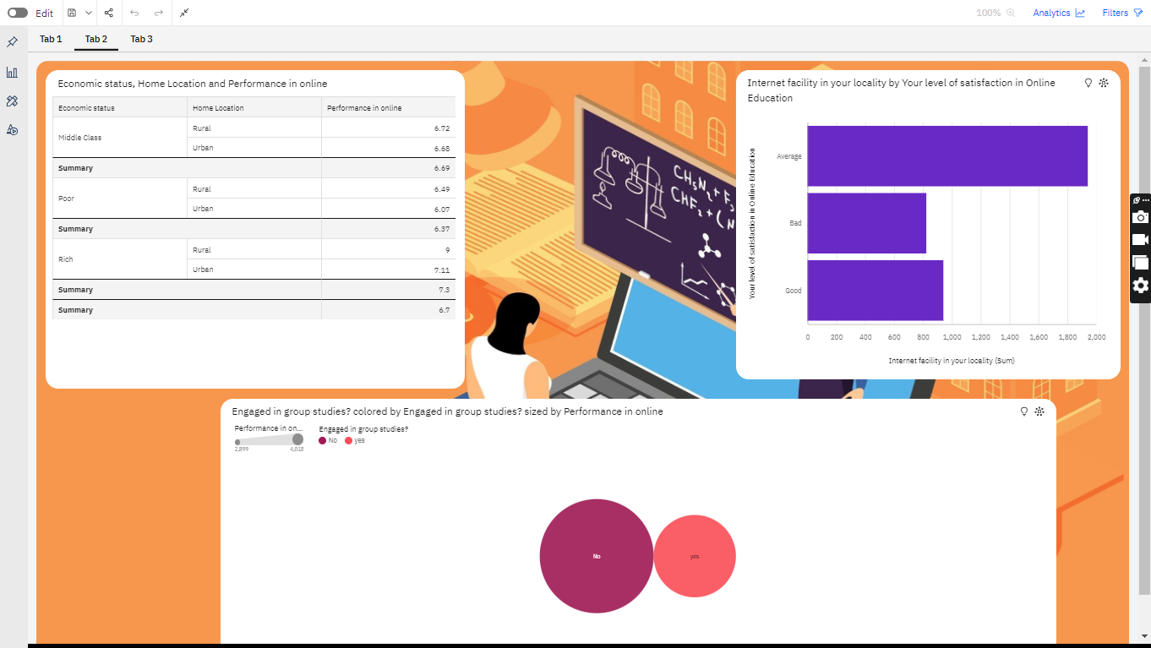

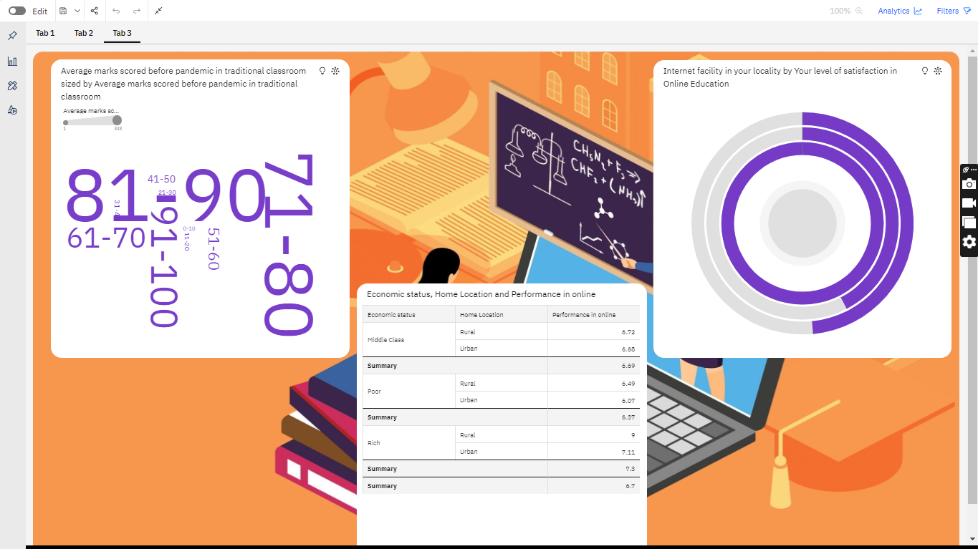

**5. Data report**

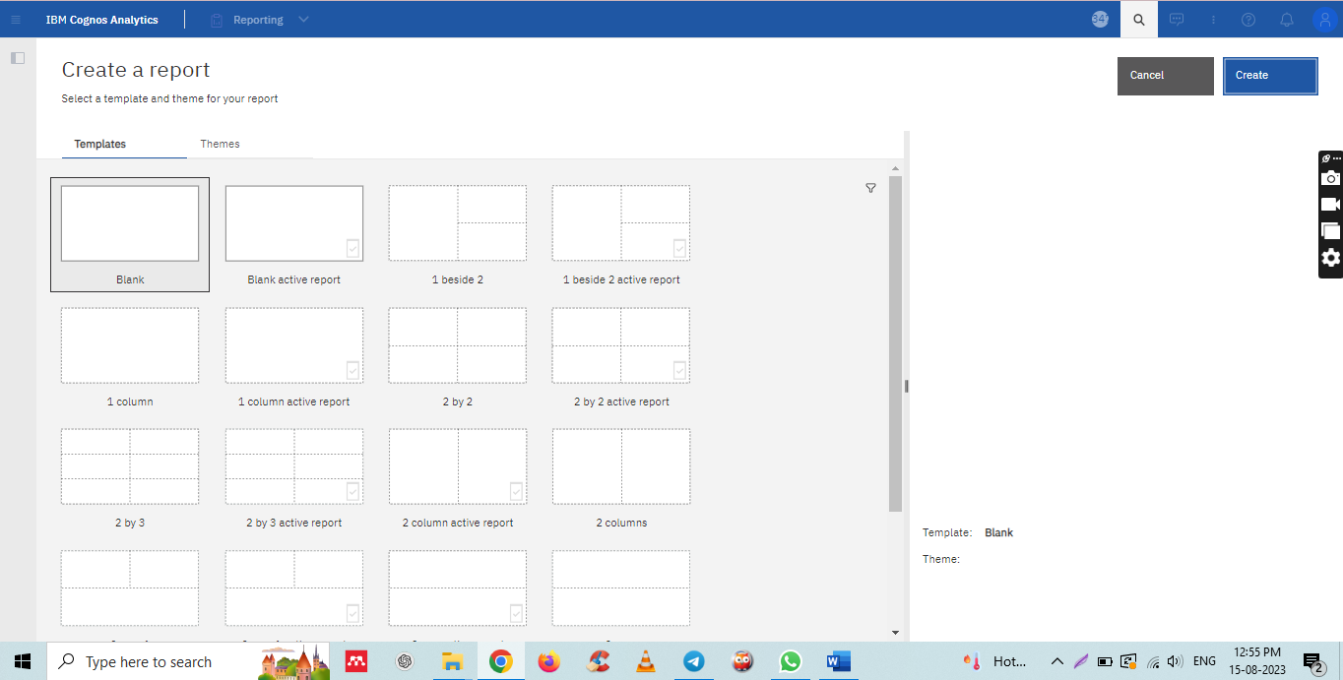

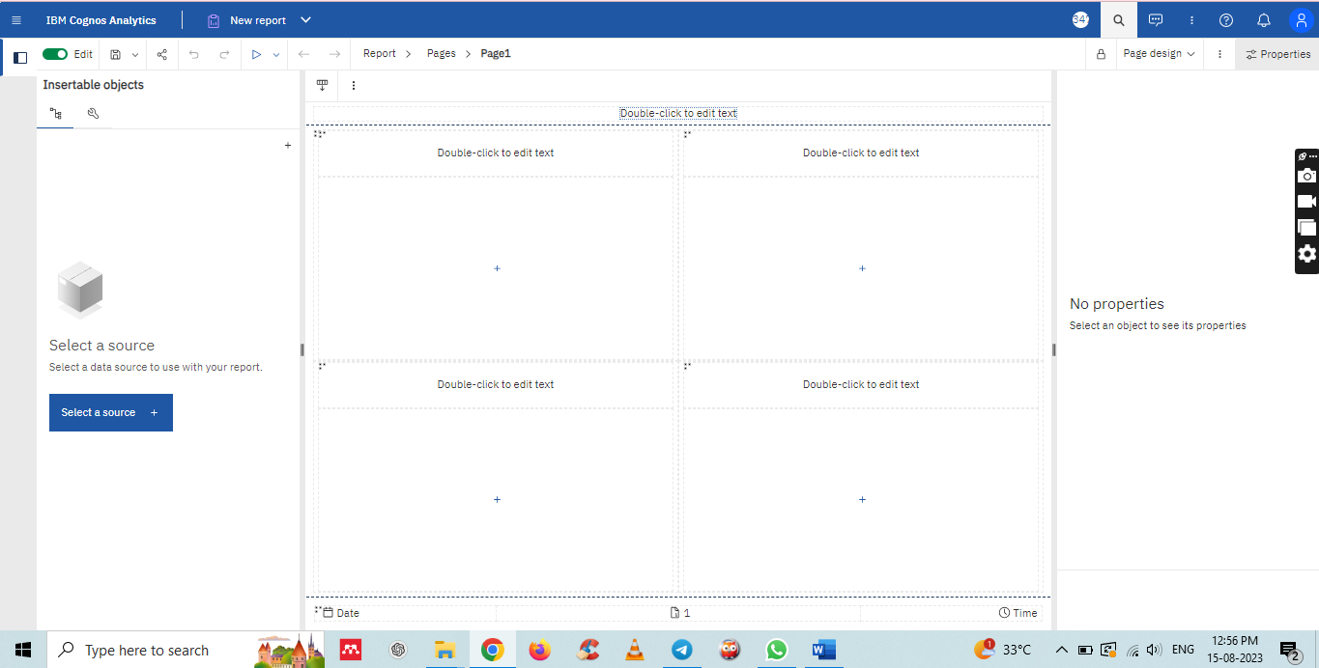

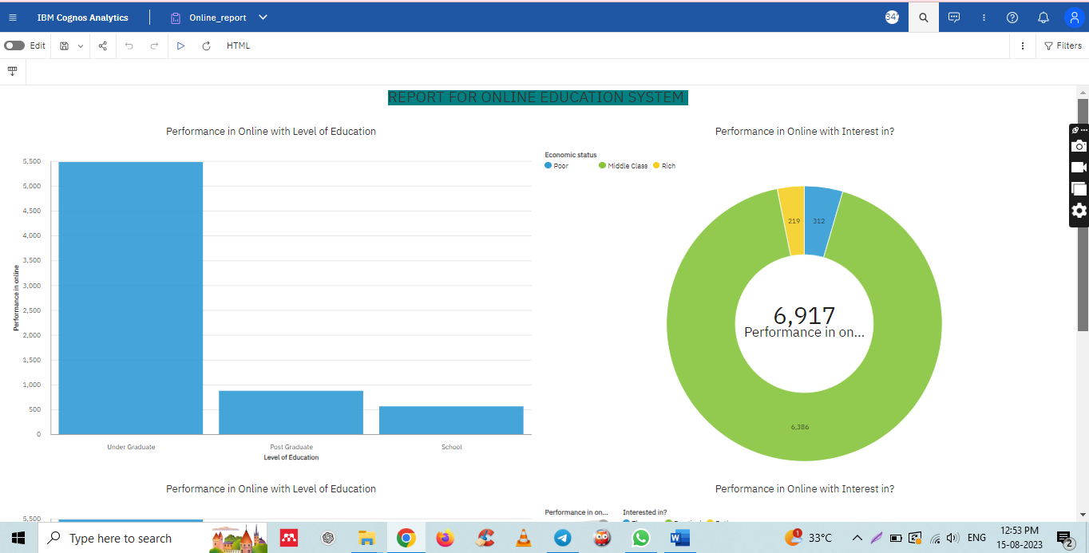

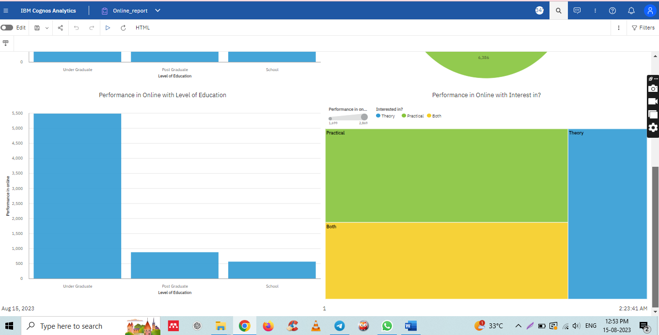

**5. Data story**

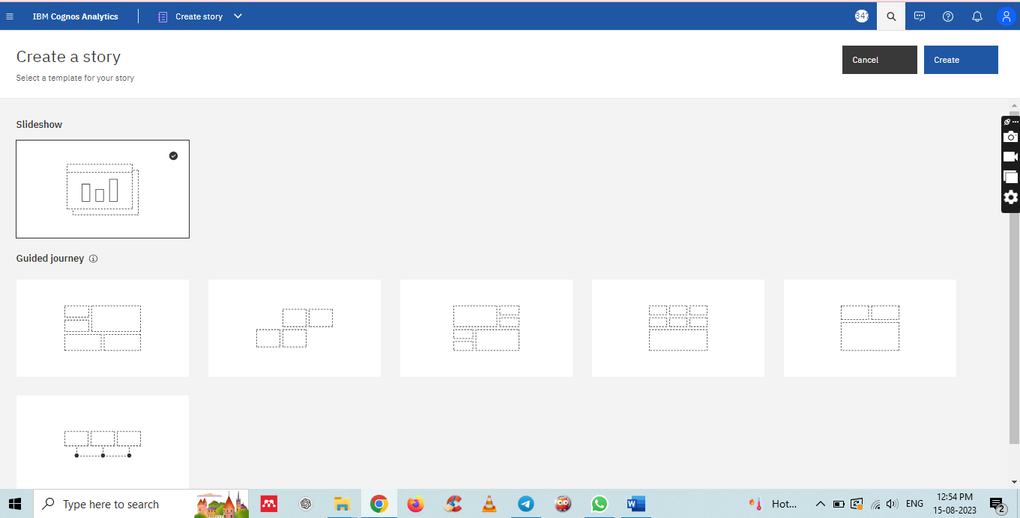

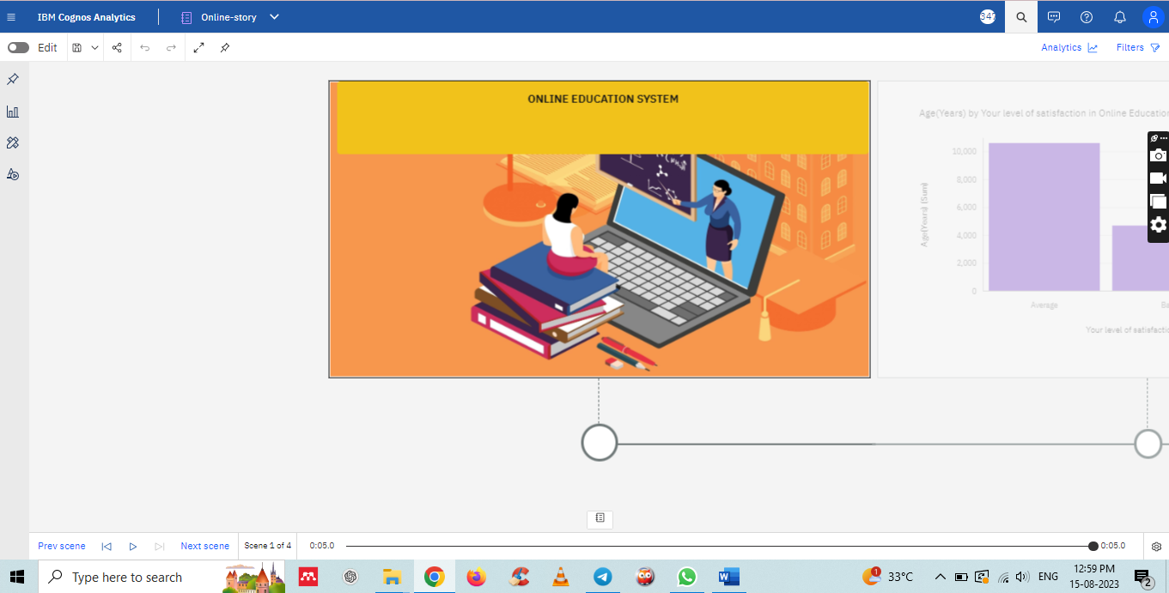

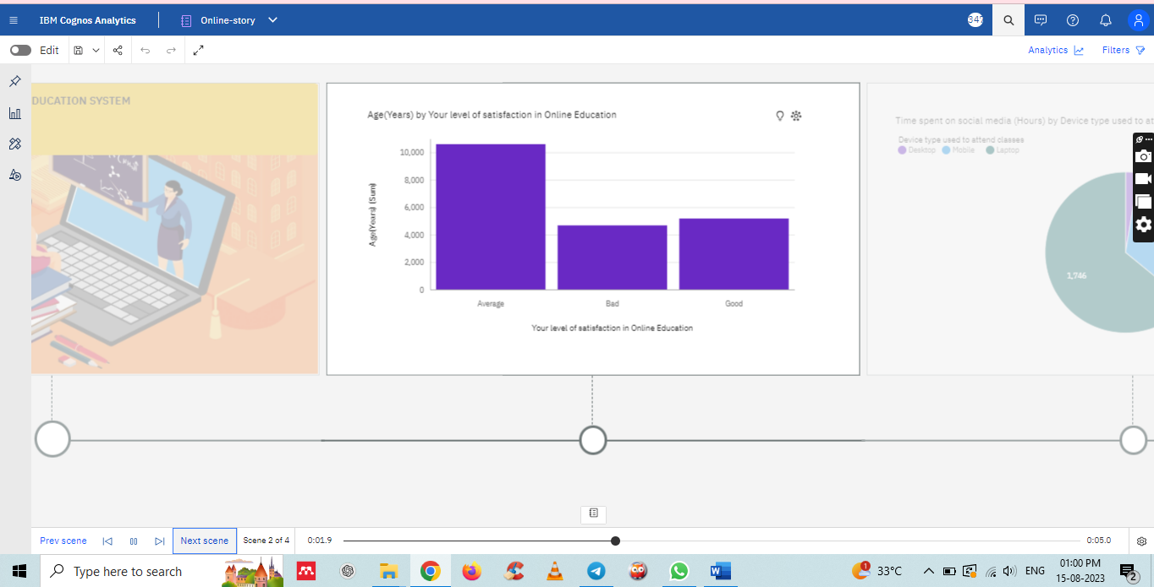

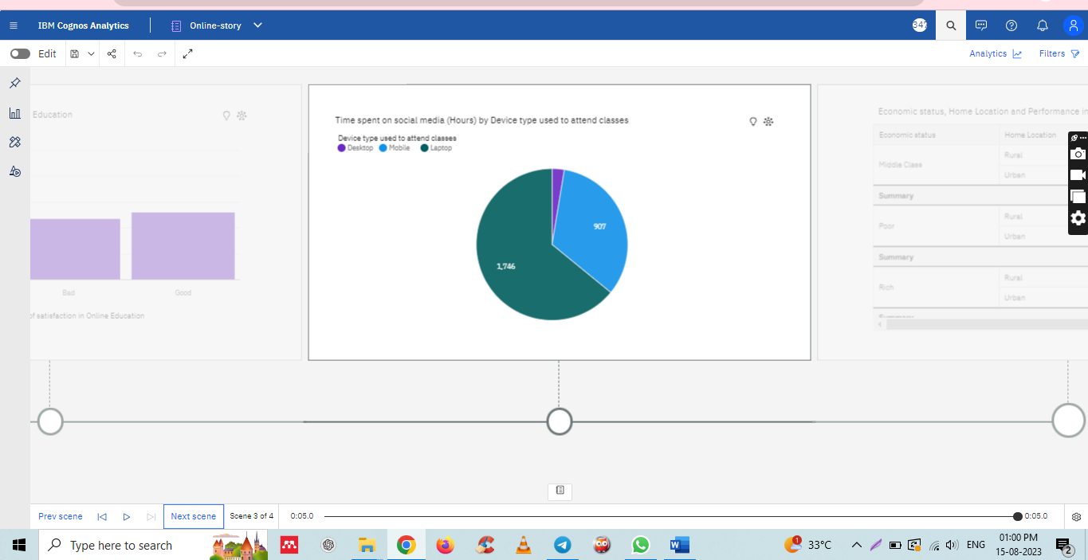

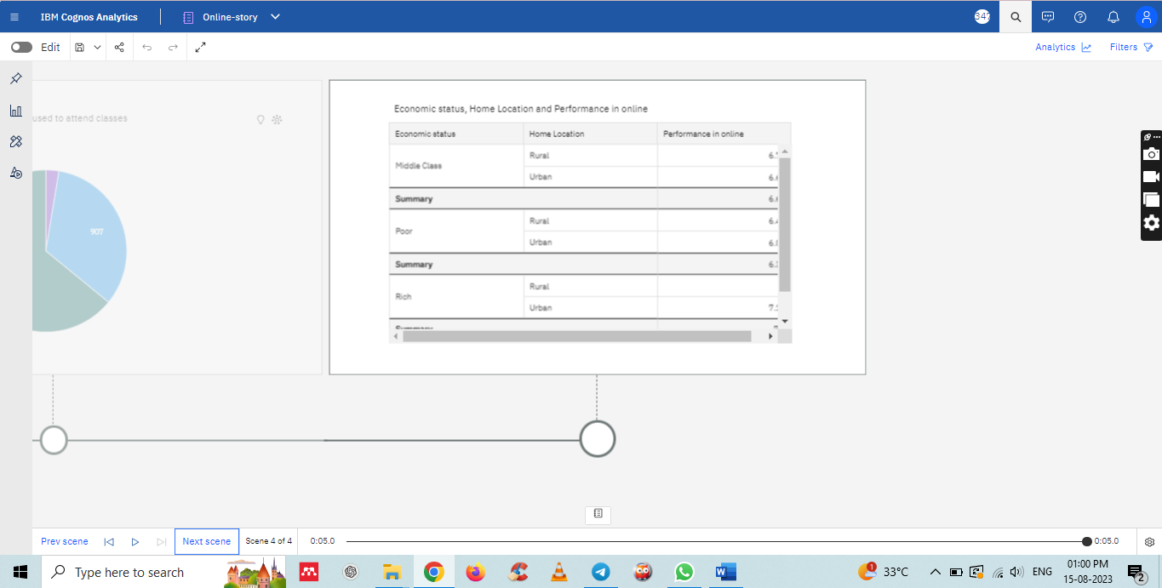

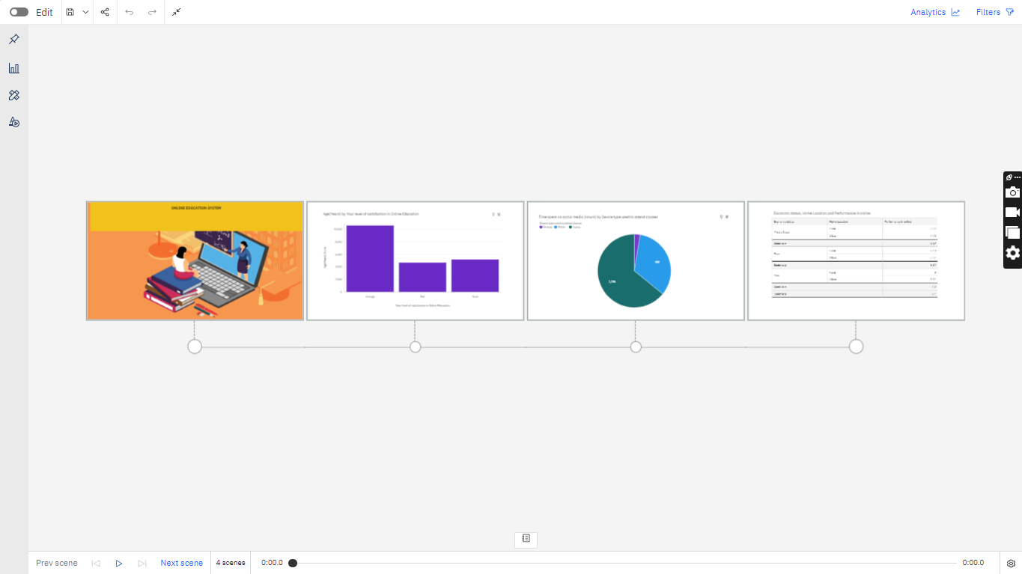

**6. performance testing**

1. Utilization Of Data Filters

* Data filters are used to customize our visualization to achieve desired output
* Apply filters while building visualizations.
* In explorations, filters are present at bottom of the ‘Fields’ option

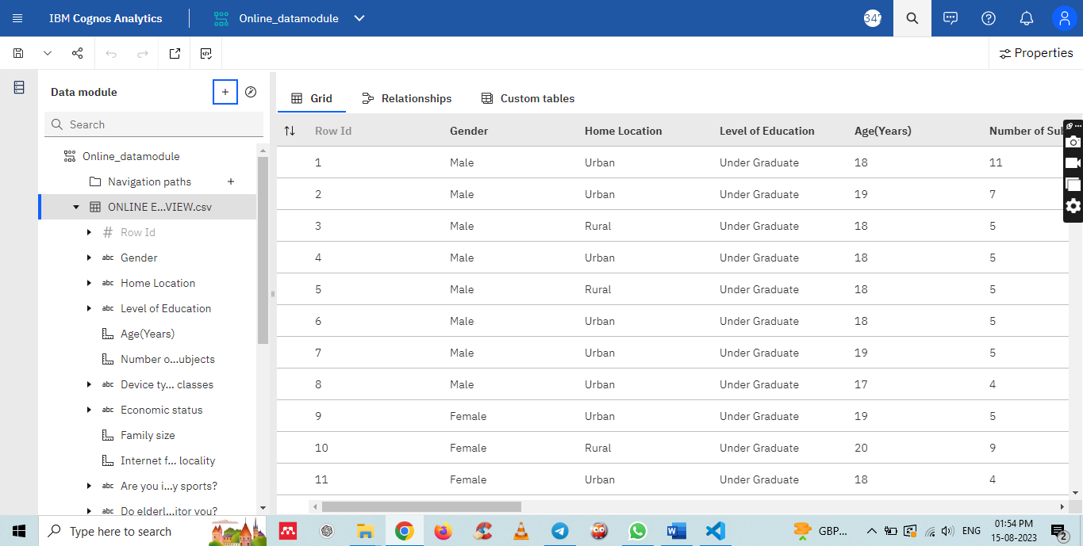

1. No Of Calculation Fields

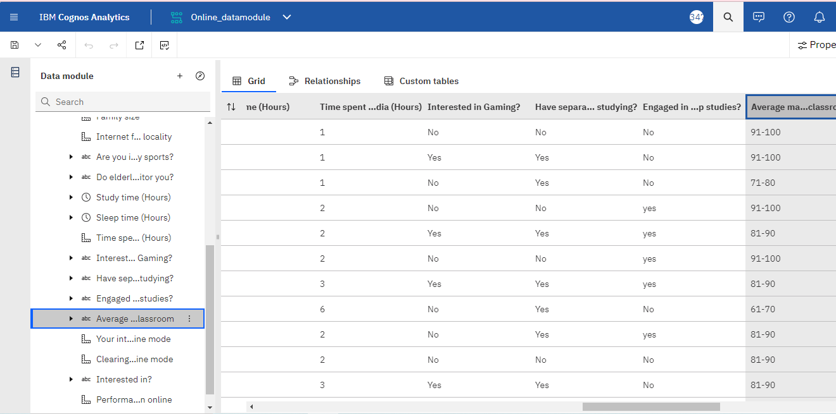

1. No Of Visualizations/ Graphs

* Column Chart: Age(Years) by Your level of satisfaction in Online Education
* Bar Chart: Internet facility in your locality by Your level of satisfaction in Online Education
* Bar chart: Performance in online by Level of Education
* Pie Chart: Time spent on social media (Hours) by Device type used to attend classes
* Packed bubbles : Engaged in group studies? colored by Engaged in group studies? sized by Performance in online
* Wordcloud: Average marks scored before pandemic in traditional classroom
* Table: Economic status, Home Location and Performance in online
* Radial Chart: Internet facility in your locality by Your level of satisfaction in Online Education

**7. web integration**

